Algebra Prelim (Spring 1992)

Instructions
Work as many problems as possible.

Problems
- Suppose that $A$, $B$, and $C$ are groups and we have homomorphisms $β:A→B$ and $γ:A→C$. Show that if $β$ is surjective and if the kernel of $β$ is a subgroup of the kernel of $γ$, then there exists a homomorphism $μ:B→C$ such that $μ∘β=γ$.
- Let $p$ be a prime and let $A$ be a normal subgroup of a finite group $G$. Suppose that the order of $A$ is $p$. Prove that $A$ is in the center of $G$.
- Let $R$ be a commutative Noetherian ring. Let $M$ be an $R$-module. For $m∈M$, the annihilator of $m$ is the set $A(m)=\{x∈R∣xm=0\}$. Show that if $m∈M$, $m≠0$, $A(m)≠0$, then there exists $r∈R$ such that $rm≠0$ and $A(rm)$ is a prime ideal.
- Let $V$ be a finite dimensional vector space over a field $F$. Let $T:V→V$ be a linear transformation.
  - Show that $T$ has a minimal polynomial $f(x)∈F[x]$. (A minimal polynomial of $T$ is a polynomial $f(x)∈F[x]$ such that $f(T)=0$ and whenever $g(x)$ is a polynomial in F[x] with $g(T)=0$, we have that $f(x)$ divides $g(x)$).
  - With $f(x)$ as in (a), suppose that $f(x)=g(x)⋅h(x)$ where $g(x)$ and $h(x)$ are relatively prime. Show directly that $V=V_{1}⊕V_{2}$ where $V_{1}$ and $V_{2}$ are subspaces which are invariant under $T$ and such that the minimal polynomial of $T$ on $V_{1}$ is $g(x)$, while the minimal polynomial of $T$ on $V_{2}$ is $h(x)$.
- Suppose that $G$ is a simple group of order 660. Prove that $G$ is isomorphic to a subgroup of $A_{12}$, the alternating group on 12 letters. (Hint: look at the Sylow 11-subgroups of $G$.)
- Let $K$ be a field and suppose that $f(t)∈K[t]$ is a polynomial of degree $n$.
  - Define what is meant by a splitting field for $f(t)$ over $K$.
  - Prove that $f(t)$ has a splitting field over $K$ which is an extension of degree at most $n!$.
- Suppose that $R$ is a ring with unit and that
- 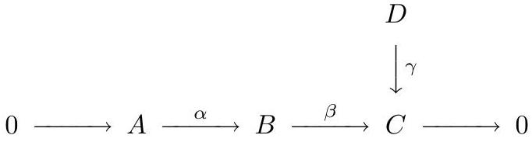
- is a diagram of $R$-modules and homomorphisms with exact row. Prove that there is an $R$-module $M$ and homomorphisms $τ$, $σ$, $θ$ such that the diagram
- 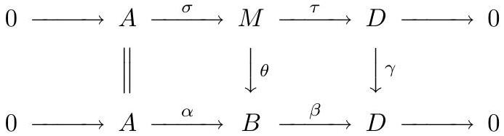
- has exact rows and commutes. (Hint: Let $M=\{(b,d)∈B⊕D∣β(b)=γ(d)\}$.)
- Let $E$ be a subfield of the complex numbers $C$ and suppose that $ζ∈C$ is a primitive $n$th root of $1$ for some positive integer $n$.
  - Is $E(ζ)$ a normal extension of $E$? Prove or give a counterexample.
  - If $E=Q$, the rationals, what is the degree of the extension of $E(ζ)$ over $E$? Explain briefly.
- Suppose that $U$ and $V$ are subspaces of a vector space $W$ over a field $F$. Suppose that $W$ has dimension $n$ and both $U$ and $V$ have dimension $s<n$. Prove that there is a subspace $X$ of dimension $n-s$ such that $X∩U=0=X∩V$. (Hint: One approach is to build a basis for $X$ by first choosing $x_{1}∈W$ such that $x_{1}∉U∪V$ (how?) then factoring out the subspace spanned by $x_{1}$ and choosing a second basis element, etc.)

